Bless Your Pastor Social Media Toolkit
Sharing the message of Bless Your Pastor with your digital community is an easy and effective way to touch as many people as possible with the news of this exciting movement to creatively care for our shepherds.

Across America and the world, pastors and their spouses faithfully serve and love the people in their congregations. Yet, our research shows that most pastor families face significant financial challenges. The Bless Your Pastor initiative is an opportunity for churches to take seriously the call to care for their pastors.

This social media toolkit makes it easy to spread the word and contains helpful content and tips to make posting a breeze:

- Bless Your Pastor social media handles, so you know who to tag.
- Prepared social media messaging for Facebook, Twitter and Instagram to simplify the posting process. Feel free to use the templated messaging as is or personalize it to make it your own!
- A Dropbox folder filled with images, social media cards, logos and videos.

Social Media Handles
Make sure to tag Bless Your Pastor in your social media posts using the handles below and use our hashtag #BlessYourPastor.

@NAEBlessYourPastor
@BlessYourPastor
@BlessYourPastor

Social Media Messaging
Use the content below to share the exciting news of Bless Your Pastor with your online community. This content is designed to foster excitement and encourage believers to support their shepherds via the Bless Your Pastor campaign.
The content below includes ready-to-use social media posts for your accounts. This content is designed to fit in at any time during the Bless Your Pastor campaign so you can use this content whether you’re early to the campaign or jumping in a bit later. Feel free to customize the posts to best suit your audience or use this templated content as is!
Show and share the love of the Lord with (INSERT PASTOR/STAFF NAME HERE), they need your support to continue to thrive! Church staff work long hours, and many are underpaid and without benefits from their churches. Learn more about how you can support our pastor and staff by following the link for easy-to-use resources to #BlessYourPastor.

BlessYourPastor.org

Here’s the link to the video: Vimeo.com/NAEvangelicals/blesspastors

Show and share the love of the Lord with (INSERT PASTOR/STAFF NAME HERE)! They need your support to continue to thrive! Church staff work long hours, and many are underpaid. Learn more about how you can support our pastor and staff by #BlessYourPastor.

BlessYourPastor.org.

Here’s the link to the video: Vimeo.com/NAEvangelicals/blesspastors

Show and share the love of the Lord with (INSERT PASTOR/STAFF NAME HERE). They need your support to continue to thrive! Church staff work long hours, and many are underpaid and without benefits from their churches. Learn more about how you can support our pastor and staff by following the link for easy-to-use resources to #BlessYourPastor.

BlessYourPastor.org

Here’s the link to the video: Vimeo.com/NAEvangelicals/blesspastors

Our church family is blessed to have (INSERT PASTOR/STAFF NAME HERE) as our shepherd, and we want to show him/her how much we appreciate his/her service. (INSERT CHURCH/ORGANIZATION NAME HERE) will be taking part in the national @NAEBlessYourPastor campaign, a movement to encourage church bodies to creatively care for their pastors. Options to care for (INSERT PASTOR/STAFF NAME HERE) are limitless but could include: financial support, professional services, home repairs and much more. Visit the #BlessYourPastor website to learn more and download free, valuable resources to get started.

BlessYourPastor.org
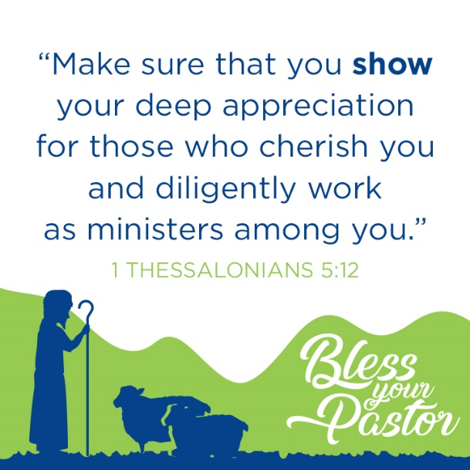

Our church family is blessed to have (INSERT PASTOR/STAFF NAME HERE) as our shepherd. (INSERT CHURCH/ORGANIZATION NAME HERE) will be taking part in the @BlessYourPastor campaign, a movement to encourage churches to care for their pastors.

BlessYourPastor.org

Our church family is blessed to have (INSERT PASTOR/STAFF NAME HERE) as our shepherd, and we want to show him/her how much we appreciate his/her service. (INSERT CHURCH/ORGANIZATION NAME HERE) will be taking part in the national @ BlessYourPastor campaign, a movement to encourage church bodies to creatively care for their pastors. Options to care for (INSERT PASTOR/STAFF NAME HERE) are limitless but could include: financial support, professional services, home repairs and much more. Visit the #BlessYourPastor website to learn more and download free, valuable resources to get started.

BlessYourPastor.org

The Lord instructs us (yes, you!) to share the blessings he has provided with our godly teachers. Need some inspiration to #BlessYourPastor? Follow the link for simple ideas to creatively care for (INSERT PASTOR/STAFF NAME HERE).

BlessYourPastor.org
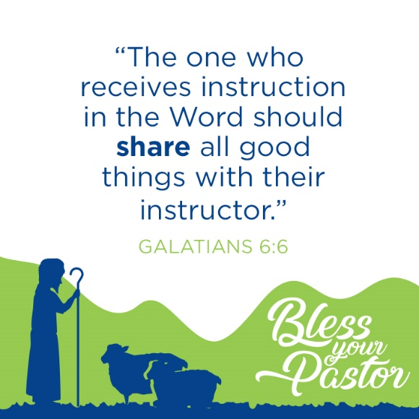

The Lord instructs us (yes, you!) to share the blessings he has provided with our godly teachers. Need some inspiration to #BlessYourPastor? Follow the link for simple ideas to creatively care for (INSERT PASTOR/STAFF NAME HERE).

BlessYourPastor.org

The Lord instructs us (yes, you!) to share the blessings he has provided with our godly teachers. Need some inspiration to #BlessYourPastor? Follow the link for simple ideas to creatively care for (INSERT PASTOR/STAFF NAME HERE).

BlessYourPastor.org

